Lab Project 0

Brandon P Trinkle

Arizona State University

Course Number: IFT 220

Professor Betty J. Lauer

March 16, 2024

Lab 0

Part A: Apporto: I am choosing Apporto for a few reasons. First, getting practice setting up machines is critical within this program. More practice and repetitions will only enforce concepts learned in other classes. Secondly, I don’t want to damage my personal computer, or configure my computer in a way that would impact how I use my computer.

Part B:

I will be using Windows snipping tool for screenshots.

I will be using Chrome for access to Apporto virtual lab - 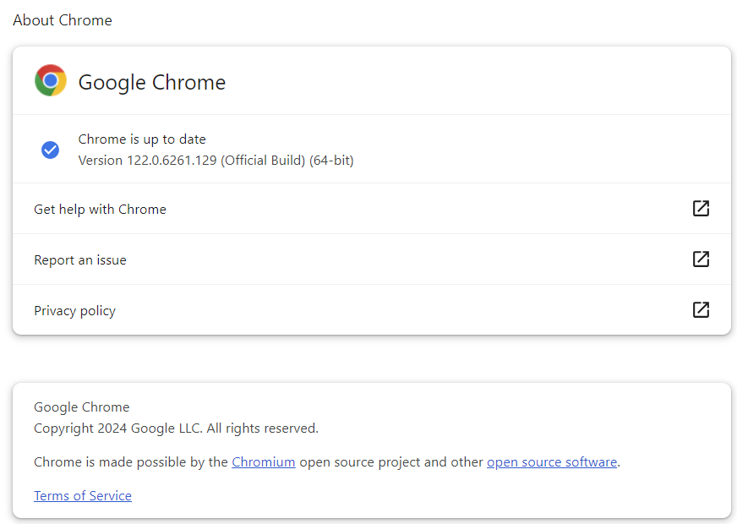

Apporto Lab Settings:

Apporto login:

Screenshot of Azure:  
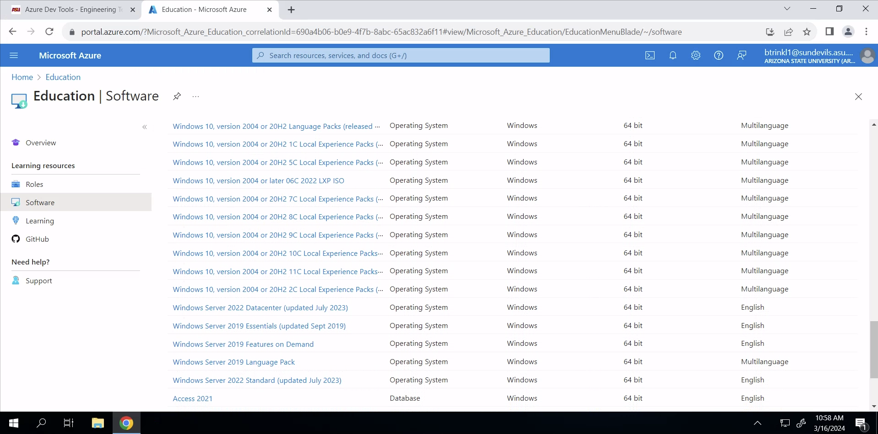

Summary:

I have used Apporto in other courses within this degree plan, so I was familiar with navigating through it. Although we did not configure any active directory settings, I did want to use Apporto to gain more experience navigating virtual desktops. Similarly with Azure, I have downloaded software from here in other courses. For example, I set up virtual machines on VirtualBox and I have upgraded my Windows version to Windows 10. In short, I did not have any issues with the objectives of this lab and navigating through Apporto and Azure and everything was successful in its operation. Within this lab I was able to confirm system settings were correct, that I was logged in under the correct username, and navigated to Azure to observe software required for the course. None of which has been downloaded yet.